The Value of Location: What Matters Most for Older Adults Considering Relocation in Sweden?
Nick Christieª, Björn Slaugª, Magnus Zingmark^{c}, Jonas Björk^{a.b}, and Susanne Iwarssonª
ª Department of Health Sciences, Faculty of Medicine, Lund University, Lund, Sweden; ^{b} Department, University, City, Country; ^{c} Department of Community Medicine and Rehabilitation, Umeå University, Umeå, Sweden

For correspondence, please contact Nick Christie, nick.christie@med.lu.se

Nick Christie, PhD, is a postdoctoral researcher and research engineer at Lund University. His research bridges health sciences and economics, focusing on housing, urban planning, and ageing, with particular attention to relocation patterns among older adults.
Björn Slaug, PhD, is an Associate Professor of Health Sciences at Lund University and a member of the Centre for Ageing and Supportive Environments (CASE) and the profile area Proactive Ageing. His research focuses on the built environment and how it can be adapted to support active and healthy ageing.
Magnus Zingmark, PhD, is an Associate Professor in Occupational Therapy and affiliated researcher at Epidemiology and Global Health, Umeå University. His work focuses on health promotion, falls prevention, and re-ablement for older adults, and he leads R&D for active and healthy ageing in the Municipality of Östersund.
Jonas Björk, PhD, is a Professor of Epidemiology at Lund University. His research focuses on sociodemographic differences in health and wellbeing, using population-based data, and he contributes to developing infrastructure for population research and public health surveillance.
Susanne Iwarsson, PhD, is Professor of Gerontology and Care for Older Adults at Lund University and Doctor Honoris Causa at Riga Stradins University, Latvia. Her research in environmental gerontology focuses on ageing, health, housing, and participation. She was the founding Coordinator of the Centre for Ageing and Supportive Environments (CASE) and the profile area Proactive Ageing, and is Coordinator of the Swedish National Graduate School on Ageing and Health (SWEAH).

Research Aim | - To explore willingness-to-pay estimates of preferred locational attributes for older individuals in Sweden considering relocation.  - Explore heterogeneity in locational preferences for older individuals in Sweden considering relocation.  - To identify differences in willingness to pay estimates famong older individuals considering relocation in Sweden.
Journals | - Housing studies – Have published a handful of studies using a DCE. Highest candidate  - Nature Ageing – appears to be rooted in medical science (DNA sequences, biological indicators, etc). No DCE studies identified. Low candidate  - Lancet -  - Health and Place -  - Urban Studies -  - Ageing Studies -  - Journal of housing and the built environment. (latex) good candidate https://link.springer.com/journal/10901
Methodological approach | - Estimate mixed logit models on Renters and Owners to identify MWTP estimates  - Extend these models to include interaction terms which facilitate identifying differences across age, gender, and health.
Methodological considerations | - Our primary focus is on tenure groups. We could shift this to another group – age groups perhaps – to move the focus of the paper.  - The heterogenous tests identify some significant differences, but they are not very strong. Exploring alternative groups could produce stronger results. (retired, civil status, city center vs urban environment, etc)
Paper structure consideration | - Perhaps combine the introduction and literature review sections.

The Value of Location: What Matters Most for Older Adults Considering Relocation in Sweden?
We examined heterogeneity in housing preferences among older adults in Sweden using discrete choice experiment data (n = 957; mean age = 72; 55.3% women). Respondents assessed trade-offs between key residential attributes, including proximity to shops and services, green spaces, access to public transportation, dedicated parking, and planned monthly expenses. We estimate mixed logit models to recover marginal willingness to pay estimates for each attribute, including interactions with age, gender, and health to capture systematic variation in preferences. The results show that individuals in the oldest age groups expressed significantly higher willingness to pay for several attributes, with values around 1.5 times greater than those of younger respondents. We identified meaningful differences by gender and tenure status that might reflect underlying patterns of social inequality in later life. These findings contribute policy-relevant evidence to support the development of age-inclusive housing strategies that address both diverse preferences and structural disparities in residential choice.
Keywords: stated choice; discrete choice; ageing in place; housing; housing preferences

Introduction
Population ageing is reshaping housing markets and welfare systems across much of the developed world. By 2050, the number of people aged 65 years or older is projected to more than double from 2021 levels, rising to 1.6 billion individuals globally (United Nations Department of Economic and Social Affairs, 2023). As the proportion of older adults continues to rise, policymakers face growing challenges in ensuring that housing and neighborhoods support autonomy, accessibility, and wellbeing in later life. Although most older adults prefer to age in place, remaining in familiar environments rather than relocating to institutional care (Wiles et al., 2012; Abramsson & Andersson, 2015), life-course events and declining physical capacity often necessitate or motivate residential change. Understanding how older individuals evaluate potential relocation alternatives is therefore essential for developing effective, age-inclusive housing strategies.
Relocation decisions in later life are shaped by a complex interplay of personal, social, and environmental factors (Roy et al., 2018). At older ages, maintaining a dwelling may become burdensome, while multi-level homes or inaccessible layouts may no longer fit changing functional abilities (Ewen et al., 2014). The departure of children or the loss of a partner can alter household needs and attachment to place (Abramsson & Andersson, 2012) while reduced mobility and increased social integration alter expectations of relocation (Robison & Moen, 2000). As the dwelling is typically the greatest source of household’s net worth, financial considerations, including the desire to release housing equity or lower housing costs after retirement, may also encourage relocation (Clark et al., 2006). Psychological factors such as loss aversion may further reinforce reluctance to move, as individuals weigh potential losses in comfort, familiarity, or community more heavily than prospective gains (Ossokina & Arentze, 2022). Nevertheless, relocation rates among older adults remain low, reflecting strong place attachment, social ties, and perceived risks associated with moving (Abramsson & Andersson, 2015).
When relocations do occur, they inevitably involve evaluating a range of neighbourhood and accessibility characteristics that influence daily life. The residential environment affects not only physical mobility and independence but also opportunities for social contact and recreation. Older adults considering relocation must therefore weigh multiple trade-offs among desirable attributes. For instance, some may prioritise proximity to green areas, while others place greater value on access to public transport or nearby shops and services. However, little is known about what and how people prioritise among such attributes. These preferences, and the implicit trade-offs they entail, are likely to vary systematically across socio-demographic groups.
The aim of this study was to explore these residential trade-offs by examining willingness to pay values of key locational and amenity attributes of older adults in Sweden considering relocation. Using data from a large-scale discrete choice experiment embedded in the Prospective RELOC-AGE project, we estimate mixed logit models to derive marginal willingness-to-pay (MWTP) measures for proximity to green space, shops, and public transport, as well as for access to dedicated parking. We further examine heterogeneity in preferences by age, gender, and health status to identify systematic variation in the valuation of these attributes. In doing so, the study builds on recent stated choice housing studies (Ossokina et al., 2020; Caplan et al., 2021; Ossokina & Arentze, 2022; Aitken et al., 2024; Lee et al., 2025), extending discrete choice methods to a Scandinavian context where ageing-in-place policies are well established but evidence on relocation preferences remains limited. By linking relocation motivations to the economic valuation of locational factors, the study offers policy-relevant insights into the housing needs of an ageing population and contributes empirical evidence to guide the planning of inclusive, adaptable living environments that support independence and quality of life in later life.

Literature Review – WORK IN PROGRESS

Materials and Methods
We used a Discrete Choice Experiment (DCE) to examine the housing attribute preferences of older adults in Sweden who are considering relocation.

Participants and data collection
The primary objective of the ongoing Prospective RELOC-AGE project, a longitudinal two-tiered mixed-method cohort investigation conducted in Sweden, is to explore the long-term dynamics associated with housing choices, relocation, and active and healthy ageing. The project was registered under the identifier NCT04765696 on ClinicalTrials.gov (U.S. National Library of Medicine, 2021). At baseline (2021) eligible participants were individuals aged 55 or older, residing in Sweden, and actively registered with an interest in relocation with one of three housing companies: two local public housing providers and a national provider of tenant-owned dwellings. A geographically diverse sample of individuals aged 55 and above was recruited across Sweden (see Figure 1).

The DCE was administered in conjunction with the second follow-up survey administered during May to October 2024., where 1,247 respondents agreed to participate in the survey via a web-based platform. After the main survey was completed, respondents were asked to take part in the optional DCE as well. Following the initial survey administration, two reminder emails were sent out to encourage participation in the DCE. The first in September 2024, to the entire respondent group, and another reminder in October 2024, targeting only those who had not taken the experiment portion of the survey. This resulted in an 80% increase from initial turnout. The final sample size of 957 individuals represent a 73% response rate of WHAT.

Development of the DCE questionnaire
Describe the iterative process of developing the questionnaire – how did we go about it, who were involved, relevant literature refs, data on preferences available from Prospective RELOC-AGE baseline and first follow-up, etc.
Prior to administering the DCE, we conducted an internal review (n = 20) and a pilot study to review the experiment (n = 56). The internal review involved researchers and staff within the research team's network. The pilot study was administered to participants in the Stakeholder Pool, a network of individuals collaborating with academia and society in the areas of ageing and health, which has been established at the Centre for Ageing and Supportive Environments (CASE) at Lund University. In both phases, respondents completed the experiment and a structured feedback form assessing the relevance of attributes, clarity of wording and levels, and overall task comprehension and burden. Feedback was instrumental in refining the experiment and clarifying the descriptions and wording of the instructions. We made several informed revisions: clarifying attribute descriptions and levels; removing redundant instructional text; fine-tuning attribute ranges; and reducing the number of choice sets to manage respondent burden.
The final DCE questionnaire included three parts: an introduction to the experiment while defining the attributes and levels, a short questionnaire on household income, costs, and planned future housing costs; and the actual experiment with nine choice sets.

Experiment design
Stated choice experiments (method ref in) encompass a range of techniques in which respondents indicate their preferences by explicitly stating their choices. In contrast to revealed choice experiments, where preferences are inferred from past behavior (method ref in), stated choice methods allow for the evaluation of decisions in a controlled environment. This controlled setting enables researchers to systematically manipulate attributes and isolate the impact of specific factors on decision-making (Hensher et al., 2015). A DCE is a type of stated choice model that presents individuals with hypothetical scenarios, allowing researchers to quantify how much value respondents place on different attributes of a product, service, or – as in this study - housing option.
In our experiment, respondents were asked to choose the most desirable housing option from a set of alternatives containing varying levels of attributes. In the nine choice scenarios that each respondent was presented with, each choice set contained various levels of the included housing attributes. Figure 2 depicts a typical choice set presented to the respondents.

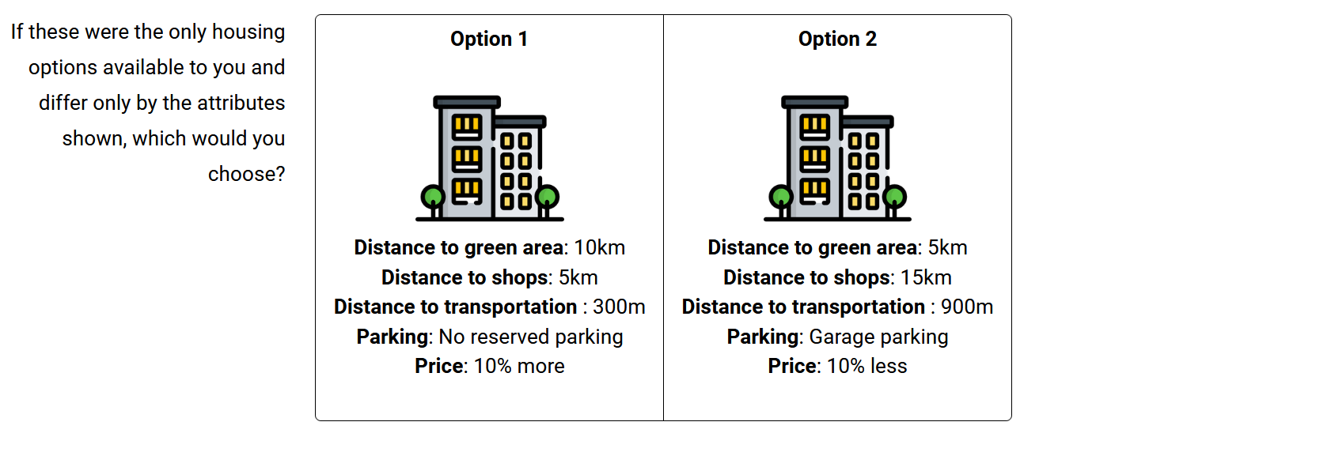
Figure 2
The choice of attributes and associated levels was guided by a combination of factors identified from the Prospective RELOC-AGE follow-up study and attributes identified in the housing literature. The selected attributes reflect key elements of housing and neighborhood quality that are particularly relevant for older adults' quality of life and residential satisfaction.
Green space proximity has been examined in numerous contexts including improved cardiometabolic and general health (Maas, 2006; Paquet et al., 2013), lower stress (Nielsen & Hansen, 2007), and improved mental health (Sturm & Cohen, 2014; Cohen-Cline et al., 2015). The attribute greenspace was defined as the distance in kilometers to green areas including parks, forests, hiking areas, and open spaces. Proximity to shops and services represents not only distance to frequent amenities, which may become more burdensome to traverse with age, but also constitutes an integral social experience to participate in the social life of communities (Lucas et al. 2016). The attribute shops represented the distance to shopping amenities such as grocery stores, malls, boutiques, and shopping centers. Access to public transportation has been shown to affect accessibility levels of populations, with significant differences identified in senior cohorts (Alsnih & Hensher, 2003; Hildebrand, 2003; Ricciardi et al., 2015). The attribute transport was defined as the distance to public transportation, such as a bus stop, metro station, or train station. Parking availability may also affect acceptability, particularly for the Prospective RELOC-AGE sample where over 90% of baseline (?) respondents (N= 1,964) had indicated access to an automobile.
Table 1. Attributes and their corresponding levels used in the experiment.
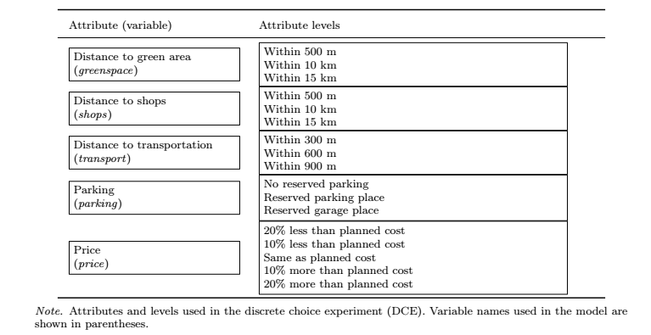
Before commencing the experiment, respondents were given a definition of each attribute, as well as an example to clarify any ambiguity in interpretation. Respondents were also instructed to base each choice on the assumption that the alternative housing options were identical in every way aside from the attributes presented. The number of choice sets was limited to nine in order to minimize the cognitive burden of the DCE while maximizing the statistical power of our tests (DeShazo & Fermo, 2002; Mangham et al., 2009; Himmler et al., 2021).
The DCE data generating process is dictated by the experimental design used to construct the choice sets. Including every combination of attribute levels in the construction of the choice sets, a full factorial design is often too large to be used in practice. To reduce the dimensionality of a full factorial design, a D-optimal subset was generated that reduces dimensionality while maintaining statistical power and balanced attribute representation (Lancsar & Louviere, 2008).

Statistical analyses
We used conventional descriptive statistics to give an overview of the sample.

Statistical models

Utilizing the discrete choice data, respondent’s choices may be modelled within a random utility theory framework, which assumes individuals choose options which maximize their utility based upon available options (Lancsar & Louviere, 2008). An underlying utility model can then be estimated where the utility that individual i derives from alternative j in a choice set t is given by:

$$U_{itj}= V_{itj}+ ε_{itj}$$
where $V_{itj}$ is the systematic component of utility, modelled as a function of the attributes of the alternative, and $ε_{itj}$is an unobserved random error term. The systematic utility is specified as:

$$V_{itj}= β1X_{itj}+ β2X_{itj}+ … + βkX_{itjk}$$
where $X_{itjk}$represents the level of attribute k for alternative j in task t, and $βk$ are the corresponding utility coefficients to be estimated. Here, $X_{itjk}$represent the respective attributes found in Table 1.
While multinomial logit (MNL) models, which assume homogeneous preferences across respondents and independently and identically distributed (i.i.d.) error terms, are commonly estimated in choice modelling, they are problematic when the objective is to uncover heterogeneity in preferences, as in our study. Recent research addresses this limitation by allowing utility coefficients to vary across individuals or groups (Caplan et al., 2021; Zhao et al., 2023; Ardeshiri et al., 2024; Aitken et al., 2024; Lee et al., 2025). We followed this line of research and estimated mixed logit (ML) models, in which the utility coefficients βi are allowed to vary randomly across individuals to account for unobserved heterogeneity in preferences (McFadden & Train, 2000):

$$β_{i}= β+ Σ_{ηi}$$
where ηi ∼ N(0,I) and Σ is the covariance matrix of the random parameters. The mixed logit model captures heterogeneity by integrating over the distribution of random coefficients using simulated maximum likelihood. Because this integral has no closed-form solution, we approximated it using simulation:

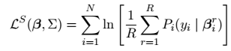
where each simulated draw βri = β + Σηir, and R denotes the number of Sobol draws used to approximate the integral over the distribution of random parameters (Train 2003). In our specification, all non-monetary attributes were treated as random and normally distributed, while the price coefficient was fixed to preserve consistency in the computation of willingness-to-pay (WTP) measures. We also allowed for full covariance among the random parameters to capture potential correlations in preferences.
We then used our price coefficient to compute monetary trade-offs for non-cost attributes. First, we estimated marginal rate of substitution (MRS) for each attribute, where the MRS for attribute k was calculated as:

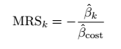
where βˆcost is the estimated coefficient on the cost attribute. Because the cost attribute was specified as a percentage change from the respondent’s expected housing cost in 10 percent intervals, we converted marginal rates of substitution (MRS) into marginal willingness to pay (MWTP) in monetary terms by scaling with 10 percent of the mean reported monthly housing cost:
$$MWTPk = MRSk × 0.10 × PC$$
where PC denotes the mean of respondents’ stated planned monthly housing cost. These MWTP estimates represent the amount, in SEK per month, that respondents were willing to pay for improvements in each housing attribute, relative to their baseline housing cost expectations.
Models were estimated in R using the logitr package (Helveston, 2023), which provides flexible estimation routines for both MNL and ML models using simulated maximum likelihood. For the ML models, we used 100 Sobol draws and multiple random starting values to ensure convergence to the global maximum (Train, 2003).
Interpretation of statistical significance
Something about how we interpret statistical significance? Or “meaningful results”…?

Ethics
The Prospective RELOC-AGE study was approved by the Swedish Ethical Review Authority (Dnr 2020–03457), in alignment with the Declaration of Helsinki and current national ethical regulations for research involving human participants. Potential participants received written information highlighting that participation was voluntary and that declining would not affect their access to housing options or public services. Informed consent was considered given upon the completion and return of the survey.

Results

Descriptive findings
Table 2 provides descriptive statistics for the study sample, disaggregated by housing tenure. Of the 957 respondents, 790 were homeowners and 167 were renters. The sample was slightly majority female (55.3%), with most participants aged 65–74 years (43.5%) followed by those aged 75+ (36.5%). Most respondents were partnered (60.6%), retired (77.1%), and lived in apartment or condominium housing (63.0%). Most had attained at least three years of university education (47.6%) and lived in city or town locations (62.2%). Most respondents described their health as “good” or better (82%). Households predominantly consisted of one or two members (95.2%), with 3.8% reporting three or more. The mean monthly household income was 46,700 SEK, and the average planned monthly housing cost was 10,500 SEK.

Table 2

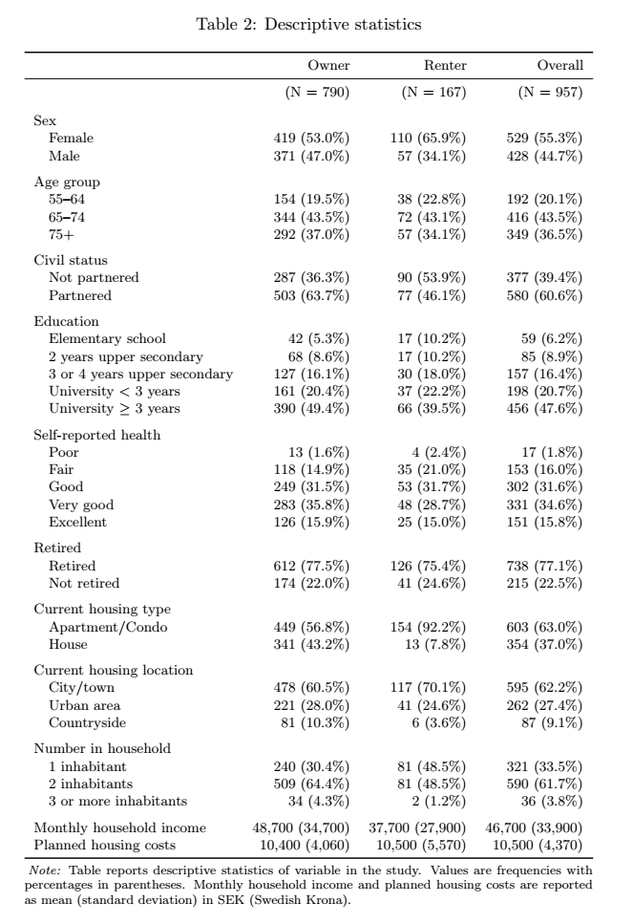

Core specification results
The reporting of core specification results begins with model results from the base specifications, which exclude interaction terms and serve as a point of comparison for subsequent models that account for heterogeneity across household types. Tables 3 and 4 present the estimation results for respondents who owned or rented their dwellings, respectively. In both sub-samples, positive (negative) coefficients indicate an increase (decrease) in average utility associated with the attribute level, relative to its reference level. Reference levels are specified as the least desirable alternative to aid in interpretation.
Across both tenure groups, all estimated coefficients exhibit the expected signs and a high degree of statistical significance. For most attributes, the mean coefficients were positive, implying that closer proximity to amenities or improved neighborhood features were preferred over their reference levels. The statistically significant standard deviation estimates further confirm the presence of unobserved preference heterogeneity among households, supporting the use of the mixed logit specification.

Table 3
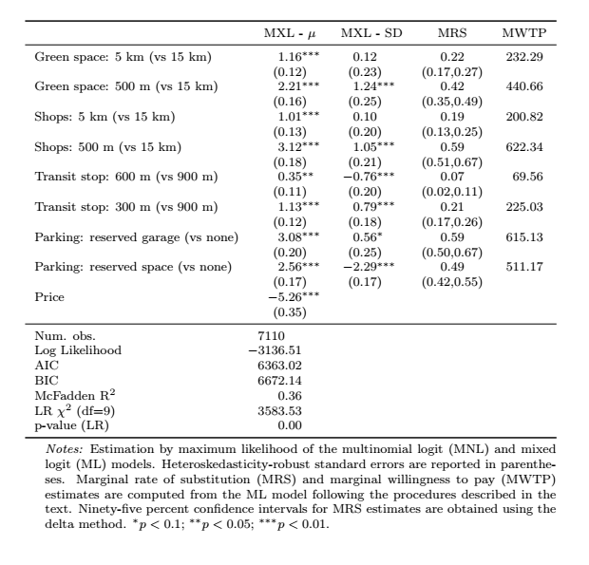
The marginal rates of substitution (MRS) are reported in column four and are computed as the ratio of attribute to price coefficients, following Equation XX. The corresponding marginal willingness to pay (MWTP) values in column six are obtained by scaling the MRS by 10 percent of the average planned housing cost for each tenure group, as described in Equation YY.
As shown in Table 3, homeowners were willing to pay substantial amounts for proximity to key neighborhood amenities. On average, homeowners were willing to pay about 440 SEK per month more to avoid living 15 km from the nearest green area and roughly 620 SEK per month to live within 500 m of shops. Access to parking was also highly valued, with MWTP estimates of 615 SEK for a reserved garage and 511 SEK for a reserved parking space. These results generally suggest an comparatively greater preference for proximity to shops and secure parking options.

Table 4
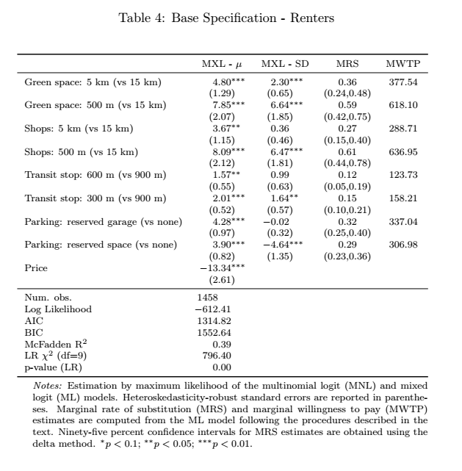
Turning to renters, Table 4 reveals similar preference patterns but with generally lower MWTP magnitudes. Renters were willing to pay 618 SEK per month to reside within 500 m of green space and 637 SEK for proximity to shops within 500. These values remained economically meaningful yet modestly below those of owners. Renters also showed strong preferences for parking access, although their MWTP for a reserved garage (337 SEK) or space (307 SEK) was roughly half that of homeowners.
Comparing across tenure types, both sub-samples placed high value on proximity to green space and retail services, but the intensity of preferences differed. Owners systematically exhibited higher MWTP for most amenities, consistent with longer-term housing commitments and investment motivations. The larger heterogeneity in standard deviation estimates among renters suggests greater variation in preferences within this sub-sample, possibly reflecting shorter planning horizons or differing residential constraints.

Overall, the base specification results demonstrate robust and consistent patterns of residential preferences. The strong fit of the mixed logit models, along with significant random parameter estimates, supports their use as the preferred framework for the heterogeneity analyses that follow.

Heterogeneity model results

Age
To assess whether preferences differed among the oldest respondents, mixed logit models were estimated with interaction terms between all housing attributes and a dummy variable for individuals aged 75 years or older. The main effects capture preferences for respondents under 75, while interaction coefficients indicate whether the marginal utilities differ for the 75+ group. MWTP values are calculated for each group separately as the ratio of the attribute to price coefficient. Statistical significance pertains only to the coefficient estimates, not to the derived MWTPs.
Among homeowners under 75 years of age, proximity to amenities generated strong and statistically significant utility gains. The baseline MWTPs were 426 SEK/month for green space within 500 m (vs 15 km), 515 SEK for shops within 500 m, and 558 SEK for a reserved garage (Table 5). following the expected monotonic distance pattern where closer proximity yields higher utility.
For homeowners aged 75 and older, two interaction terms wre statistically significant. The coefficient for green space × 75+ was negative (−0.68, p < 0.05), indicating that older homeowners derive less marginal utility from nearby green areas than younger respondents. The corresponding MWTP for green space within 500 m was 359 SEK/month, lower than the baseline.
In contrast, the coefficient transit stop × 75+ is positive (0.47, p < 0.05), suggesting that the oldest homeowners place greater value on transit accessibility. Their MWTP for a 600 m transit stop is approximately 465 SEK/month, compared with 421 SEK for younger respondents. These results imply that while overall preference patterns are stable across age groups, the relative importance of green space and public transport accessibility shifts modestly among homeowners aged 75+.
Among renters under 75 years, MWTPs mirror those of homeowners in relative terms: 489 SEK for green space within 500 m, 518 SEK for shops within 500 m, and 286–323 SEK for parking amenities. For renters aged 75+, the only statistically significant interaction was shops × 75+ (−2.38, p < 0.05). This indicates that the oldest renters place less marginal utility on proximity to shops compared with younger renters, potentially reflecting a shift away from retail accessibility as a decisive housing attribute in advanced age. Other interactions, including those for green space, transit, and parking, were statistically insignificant, although MWTP values remained positive, suggesting continued but more modest preferences for these amenities.
Both specifications demonstrate good fit. The homeowner model yield a log-likelihood of −3125.21 (McFadden R² = 0.37), and the renter model −610.58 (R² = 0.40). Likelihood-ratio tests reject the null of no interaction effects (p < 0.001 for both models), confirming that age heterogeneity contributes significantly to explaining observed choice behavior.

Table 5- Interaction Regression - 75+
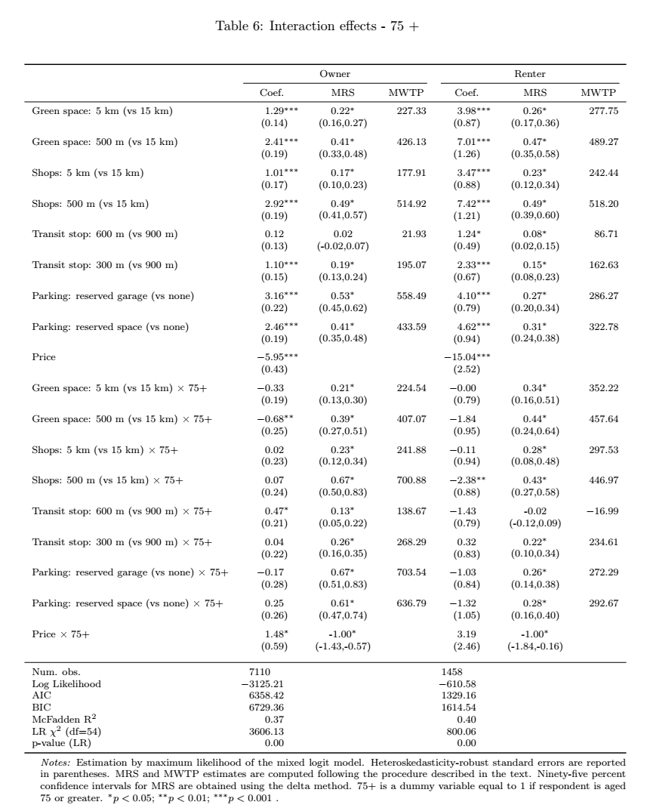

Gender
To examine whether housing preferences differ by gender, mixed logit models were estimated with interaction terms between all housing attributes and a male indicator (Men = 1). Main effects capture preferences for female respondents, while the interaction coefficients represent deviations for males. MWTPs are computed separately for each gender as the ratio of their respective attribute and price coefficients. Statistical significance pertains exclusively to the coefficient estimates.
Among female homeowners, the coefficients indicate strong and statistically significant preferences for proximity-based amenities. The corresponding MWTPs were 492 SEK/month for green space within 500 m, 653 SEK for shops within 500 m, and 428–542 SEK for parking amenities.
For male homeowners, most interaction terms were not statistically significant, suggesting broadly similar preference structures across genders. The interaction coefficient for green space (500 m) was negative (−0.53, p < 0.05), indicating that men derive slightly less utility from nearby green areas compared with women. Conversely, the coefficient for shops (500 m) was positive (0.58, p < 0.05), implying stronger utility from retail proximity among male homeowners. These two differences were the only statistically significant gender interactions.
All other interactions, including those for transit, parking, and price, were statistically insignificant. However, MWTP magnitudes remained higher for men in absolute terms for most amenities, particularly parking (approximately 1,186 SEK/month for a reserved garage and 958 SEK for a reserved space), suggesting stronger revealed preferences for vehicle access even though the coefficient differences were not significant.
Among renters, coefficient estimates revealed no statistically significant gender interactions. The main effects for female renters indicated positive and significant preferences for proximity to green space and shops, with corresponding MWTPs of roughly 434–437 SEK/month. Male renters’ coefficients were directionally similar, though MWTP magnitudes were modestly higher (≈490 SEK for green space and 619 SEK for shops), indicating consistent but not statistically distinct preferences.
The absence of significant interaction effects among renters likely reflects smaller sample size and more constrained choice sets relative to homeowners.
The results suggest that gender differences in housing preferences are limited in statistical terms, though some systematic patterns are evident. Among homeowners, men show weaker preferences for green space but stronger preferences for shop proximity relative to women. Parking MWTPs are higher for men but not statistically distinct, while transit accessibility appears gender-neutral. The consistency of results across tenure groups indicates that gendered patterns in housing choice are modest in magnitude, with significant variation only for specific amenity types

Table 6 - Interaction Regression - Sex
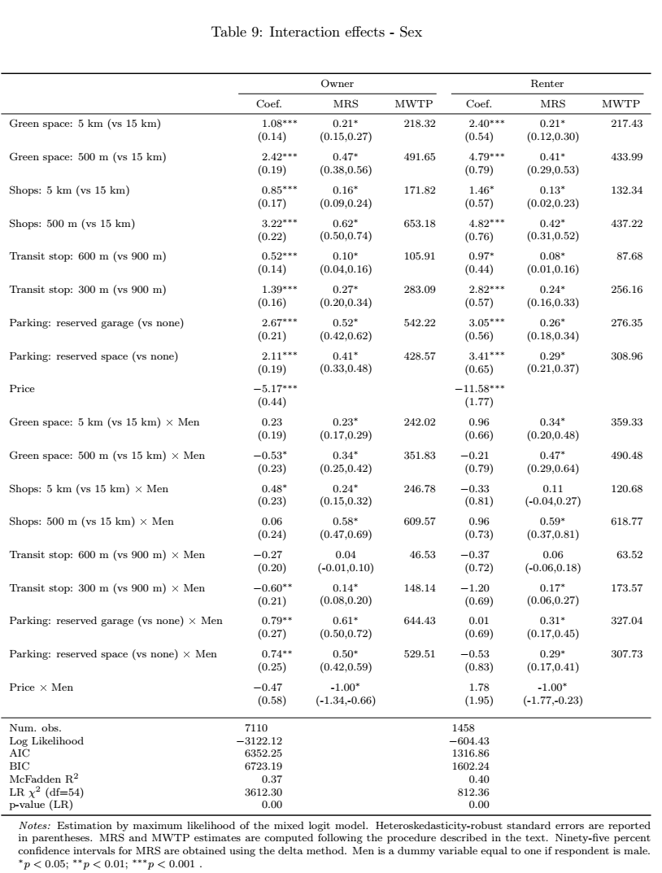

Health
To capture health-related variation in preferences, mixed logit models were estimated with interaction terms between housing attributes and a dummy equal to 1 for respondents reporting “good” or better health (reference = fair/poor). Main effects therefore represent the less healthy group, while interaction coefficients measure how preferences differ for healthier respondents. MWTPs are computed for each group independently; statistical significance refers solely to the coefficient estimates.
For homeowners, several coefficients differed by health status, though few reached conventional significance thresholds. The interactions for green space proximity were positive but not statistically significant, indicating that healthier respondents tended to value outdoor and recreational access more, though the difference is not statistically confirmed. The parking interactions were negative but insignificant, suggesting that respondents in poorer health may rely more on private vehicle access for mobility.
The general pattern of MWTPs supports these interpretations: healthier homeowners exhibit higher MWTPs for outdoor and mobility-related attributes (≈380–420 SEK higher for green space and shops within 500 m), while those in poorer health display somewhat greater MWTP for parking amenities (≈100–150 SEK higher). Although not statistically significant, these directional trends are consistent with theoretical expectations regarding physical capacity and environmental engagement.
Among renters, no interaction coefficients were statistically significant. Nonetheless, MWTPs suggest similar patterns: renters in good health exhibited somewhat higher valuations for green space and public transport, whereas those in poorer health showed elevated MWTP for parking convenience. These effects are modest in magnitude and imprecisely estimated, likely due to smaller sample size and limited variation in self-reported health among renters.
The health heterogeneity results indicate that preference structures vary with physical condition, though most differences were not statistically significant. Healthier respondents displayed higher valuations for attributes that support outdoor activity and local engagement, while those in poorer health prioritized accessibility and convenience features. These patterns suggest that health status influences housing attribute trade-offs in predictable ways, even if the estimated differences are not statistically strong.

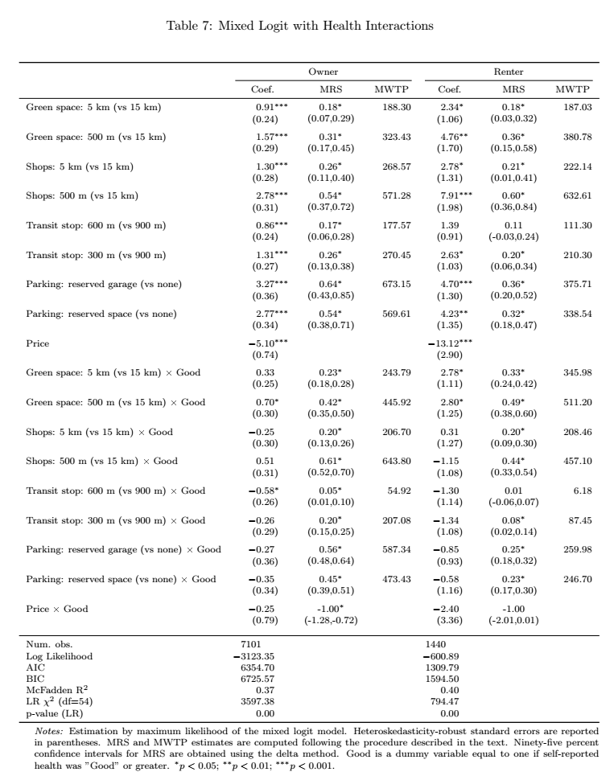

Discussion – WORK IN PROGRESS

Conclusion – WORK IN PROGRESS

References
Abramsson, M., & Andersson, E. K. (2012). Residential Mobility Patterns of Elderly—Leaving the House for an Apartment. Housing Studies, 27(5), 582–604. https://doi.org/10.1080/02673037.2012.697553
Abramsson, M., & Andersson, E. K. (2015). Changing locations: Central or peripheral moves of seniors? Journal of Housing and the Built Environment, 30(4), 535–551. https://doi.org/10.1007/s10901-014-9427-0
Aitken, D., Willis, K., & Gilroy, R. (2024). Do older homebuyers prefer dwellings with accessibility and adaptability features? Findings from an exploratory study. Housing Studies, 39(3), 608–630. https://doi.org/10.1080/02673037.2022.2060944
Alsnih, R., & Hensher, D. A. (2003). The mobility and accessibility expectations of seniors in an aging population. Transportation Research Part A: Policy and Practice, 37(10), 903–916. https://doi.org/10.1016/S0965-8564(03)00073-9
Ardeshiri, A., Washington, L., Vij, A., Leishman, C., & Beer, A. (2024). Housing preferences for owner-occupied versus investment properties in Sydney, Australia. Housing Studies, 0(0), 1–23. https://doi.org/10.1080/02673037.2024.2428749
Caplan, A. J., Akhundjanov, S. B., & Toll, K. (2021). Measuring heterogeneous preferences for residential amenities. Regional Science and Urban Economics, 87, 103646. https://doi.org/10.1016/j.regsciurbeco.2021.103646
Clark, W., Deurloo, M., & Dieleman, F. (2006). Residential Mobility and Neighbourhood Outcomes. Housing Studies, 21(3), 323–342. https://doi.org/10.1080/02673030600585946
Cohen-Cline, H., Turkheimer, E., & Duncan, G. E. (2015). Access to green space, physical activity and mental health: A twin study. Journal of Epidemiology and Community Health, 69(6), 523–529. https://doi.org/10.1136/jech-2014-204667
DeShazo, J. R., & Fermo, G. (2002). Designing Choice Sets for Stated Preference Methods: The Effects of Complexity on Choice Consistency. Journal of Environmental Economics and Management, 44(1), 123–143. https://doi.org/10.1006/jeem.2001.1199
Ewen, H. H., Hahn, S. J., Erickson, M. A., & Krout, J. A. (2014). Aging in Place or Relocation? Plans of Community-Dwelling Older Adults. Journal of Housing for the Elderly, 28(3), 288–309. sih. https://doi.org/10.1080/02763893.2014.930366
Helveston, J. P. (2023). logitr: Fast Estimation of Multinomial and Mixed Logit Models with Preference Space and Willingness-to-Pay Space Utility Parameterizations. Journal of Statistical Software, 105(10). https://doi.org/10.18637/jss.v105.i10
Hensher, D. A., Rose, J. M., & Greene, W. H. (2015). Applied Choice Analysis (2nd ed.). Cambridge University Press. https://doi.org/10.1017/CBO9781316136232
Hildebrand, E. D. (2003). Dimensions in elderly travel behaviour: A simplified activity-based model using lifestyle clusters.
Himmler, S., Soekhai, V., van Exel, J., & Brouwer, W. (2021). What works better for preference elicitation among older people? Cognitive burden of discrete choice experiment and case 2 best-worst scaling in an online setting. Journal of Choice Modelling, 38, 100265. https://doi.org/10.1016/j.jocm.2020.100265
Lancsar, E., & Louviere, J. (2008). Conducting Discrete Choice Experiments to Inform Healthcare Decision Making: A User??s Guide. PharmacoEconomics, 26(8), 661–677. https://doi.org/10.2165/00019053-200826080-00004
Lee, P.-H., Han, Q., de Vries, B., & Juan, Y.-K. (2025). Heterogeneities in willingness to pay for circular affordable housing: Insight from young users. Housing Studies, 40(11), 2450–2480. https://doi.org/10.1080/02673037.2024.2404063
Maas, J. (2006). Green space, urbanity, and health: How strong is the relation? Journal of Epidemiology & Community Health, 60(7), 587–592. https://doi.org/10.1136/jech.2005.043125
Mangham, L. J., Hanson, K., & McPake, B. (2009). How to do (or not to do) … Designing a discrete choice experiment for application in a low-income country. Health Policy and Planning, 24(2), 151–158. https://doi.org/10.1093/heapol/czn047
McFadden, D. (1974). The measurement of urban travel demand. Journal of Public Economics, 3(4), 303–328. https://doi.org/10.1016/0047-2727(74)90003-6
McFadden, D., & Train, K. (2000). Mixed MNL models for discrete response. Journal of Applied Econometrics, 15(5), 447–470. https://doi.org/10.1002/1099-1255(200009/10)15:5<447::AID-JAE570>3.0.CO;2-1
Nielsen, T. S., & Hansen, K. B. (2007). Do green areas affect health? Results from a Danish survey on the use of green areas and health indicators. Health & Place, 13(4), 839–850. https://doi.org/10.1016/j.healthplace.2007.02.001
Ossokina, I. V., & Arentze, T. A. (2022). Reference-dependent housing choice behaviour: Why are older people reluctant to move? Housing Studies, 1–19. https://doi.org/10.1080/02673037.2022.2151984
Ossokina, I. V., Arentze, T. A., Van Gameren, D., & Van Den Heuvel, D. (2020). Best living concepts for elderly homeowners: Combining a stated choice experiment with architectural design. Journal of Housing and the Built Environment, 35(3), 847–865. https://doi.org/10.1007/s10901-019-09716-5
Paquet, C., Orschulok, T. P., Coffee, N. T., Howard, N. J., Hugo, G., Taylor, A. W., Adams, R. J., & Daniel, M. (2013). Are accessibility and characteristics of public open spaces associated with a better cardiometabolic health? Landscape and Urban Planning, 118, 70–78. https://doi.org/10.1016/j.landurbplan.2012.11.011
Ricciardi, A. M., Xia, J., & Currie, G. (2015). Exploring public transport equity between separate disadvantaged cohorts: A case study in Perth, Australia. Journal of Transport Geography, 43, 111–122. https://doi.org/10.1016/j.jtrangeo.2015.01.011
Robison, J. T., & Moen, P. (2000). A Life-Course Perspective on Housing Expectations and Shifts in Late Midlife. Research on Aging, 22(5), 499–532. https://doi.org/10.1177/0164027500225003
Roy, N., Dubé, R., Després, C., Freitas, A., & Légaré, F. (2018). Choosing between staying at home or moving: A systematic review of factors influencing housing decisions among frail older adults. PLOS ONE, 13(1), e0189266. https://doi.org/10.1371/journal.pone.0189266
Sturm, R., & Cohen, D. (2014). Proximity to Urban Parks and Mental Health.
Toth, M., Palmer, L., Bercaw, L., Voltmer, H., & Karon, S. L. (2022). Trends in the Use of Residential Settings Among Older Adults. The Journals of Gerontology: Series B, 77(2), 424–428. https://doi.org/10.1093/geronb/gbab092
Train, K. (Ed.). (2003). Discrete choice methods with simulation. Cambridge University Press.
United Nations Department of Economic and Social Affairs. (2023). World Social Report 2023: Leaving No One Behind in an Ageing World. United Nations. https://doi.org/10.18356/9789210019682
Wiles, J. L., Leibing, A., Guberman, N., Reeve, J., & Allen, R. E. S. (2012). The Meaning of “Aging in Place” to Older People. The Gerontologist, 52(3), 357–366. https://doi.org/10.1093/geront/gnr098
Zhao, L., Szajnfarber, Z., Broniatowski, D., & Helveston, J. P. (2023). Using conjoint analysis to incorporate heterogeneous preferences into multimodal transit trip simulations. Systems Engineering, 26(4), 438–448. https://doi.org/10.1002/sys.21670

